**COVID-19: Then vs Now**

**Report and Analysis**

**Introduction**

This report will include data and information regarding Covid-19 Then vs Now and will be used to answer a user story. The data utilized for answering the user story consists of 121,034 rows and 65 columns all related to Covid-19 statistics and metrics. These ranged from the location, date, cases, deaths, vaccinations and other similar factors. Meaning there are 121,034 rows and relevant information contained within the data.

The questions we are tasked with are, “Which Countries have had the best response to COVID over the 2-year span? Which Countries have had the worst response? I.e., are the numbers of cases over the 2 years rising, declining or no change? Which columns are going to be useful in answering these questions? Are there any other factors that could be considered?”. In this report I will be discussing more in depth in the following sections about the data, methods used, and the overall results.

**Data:**  
To start off this analysis I initially gathered all the data into a Data Frame for inspection of rows which will be relevant to the user story. After the initial inspection I noticed numerous columns would be unneeded for this analysis. I decided I will be needing to keep 6 of the 65 columns in the data, which are continent, location, date, total cases, new cases, and total vaccinations.

**Method:**

After loading the data, I picked the columns that seemed relevant for the task in general, which are: continent, location, date, total cases, new cases, and total vaccinations. Then to compare the values for each continent and location I loaded the minimum and maximum values for these columns and loaded the mean of the columns to see the average of the data frame.

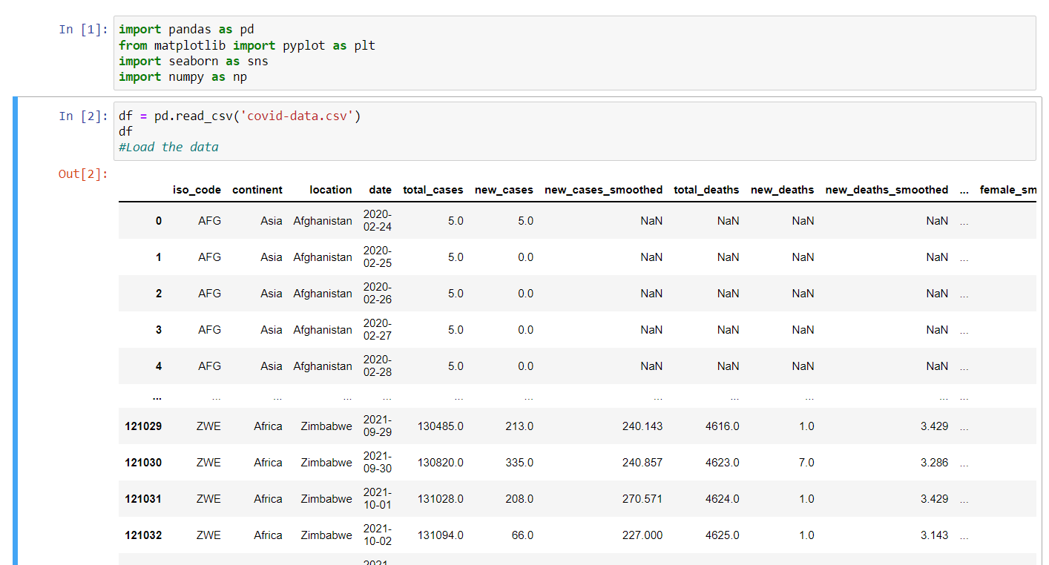

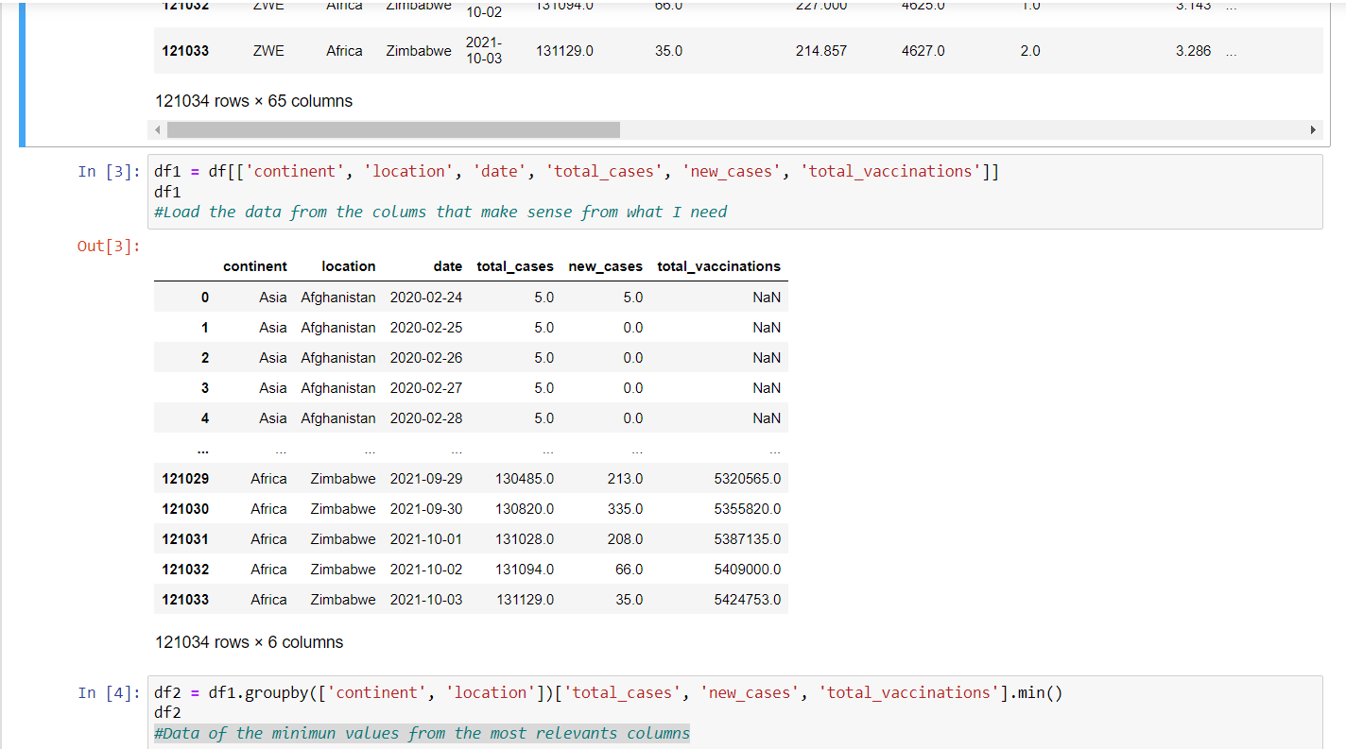

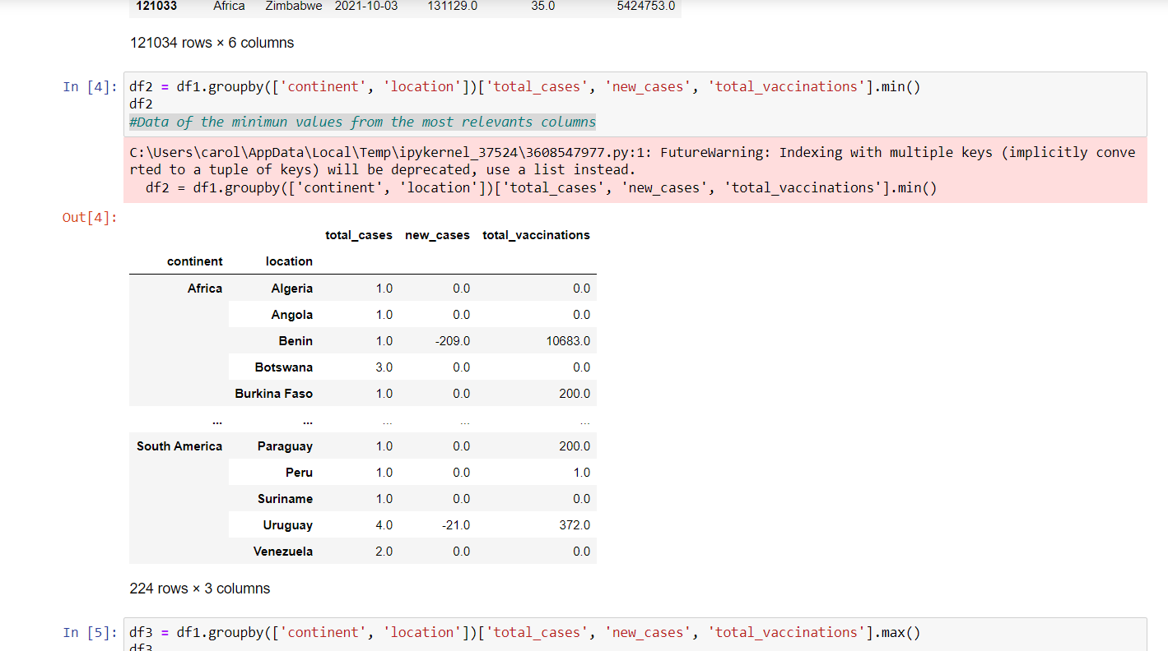

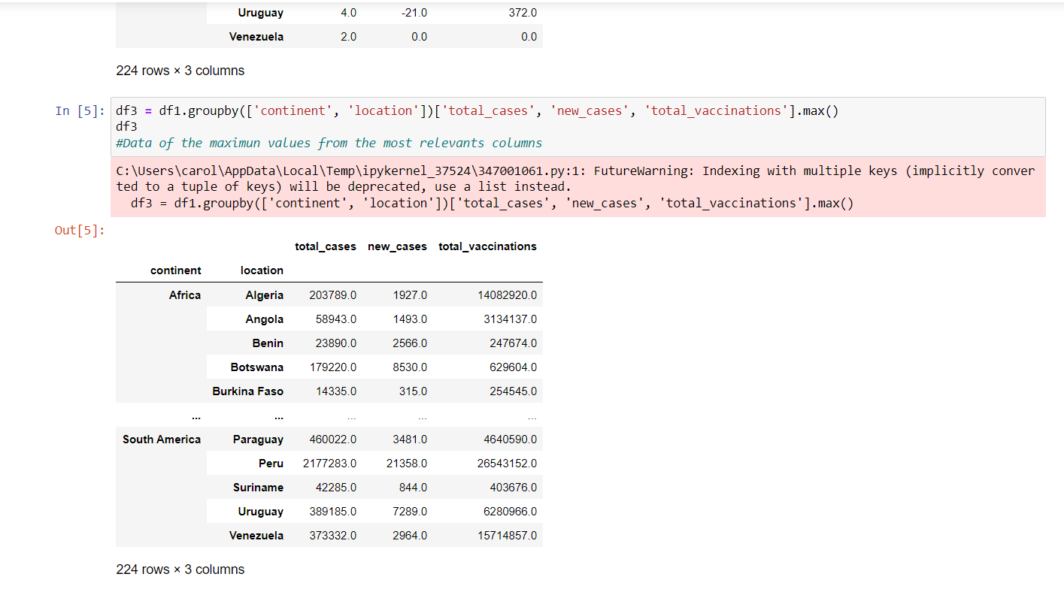

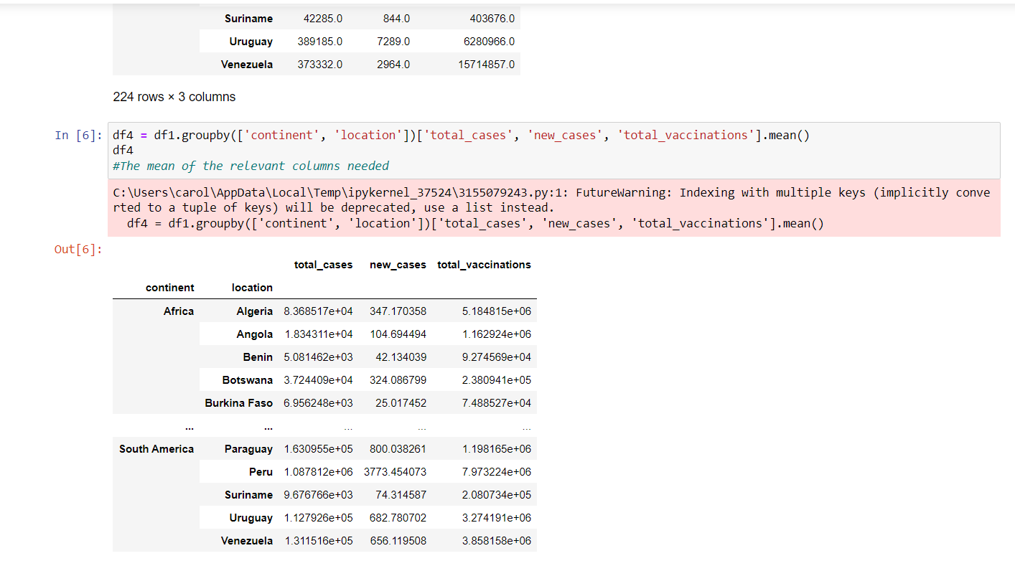

To see the response to Covid over the 2-year span and which countries had the worst response I loaded the data of the location, date, total cases, new cases and total vaccinations per continent.

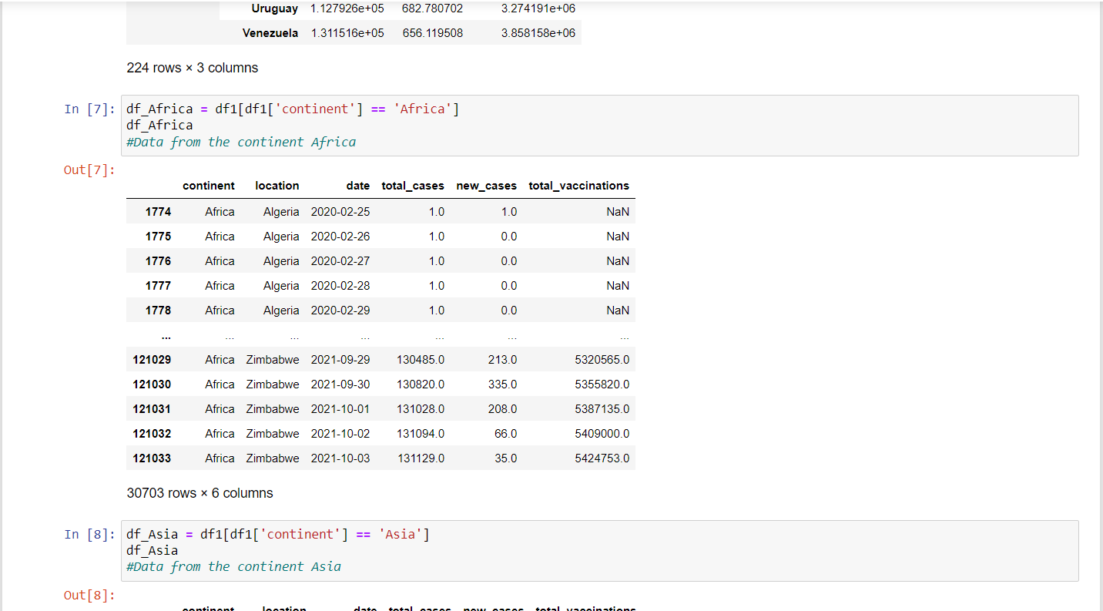

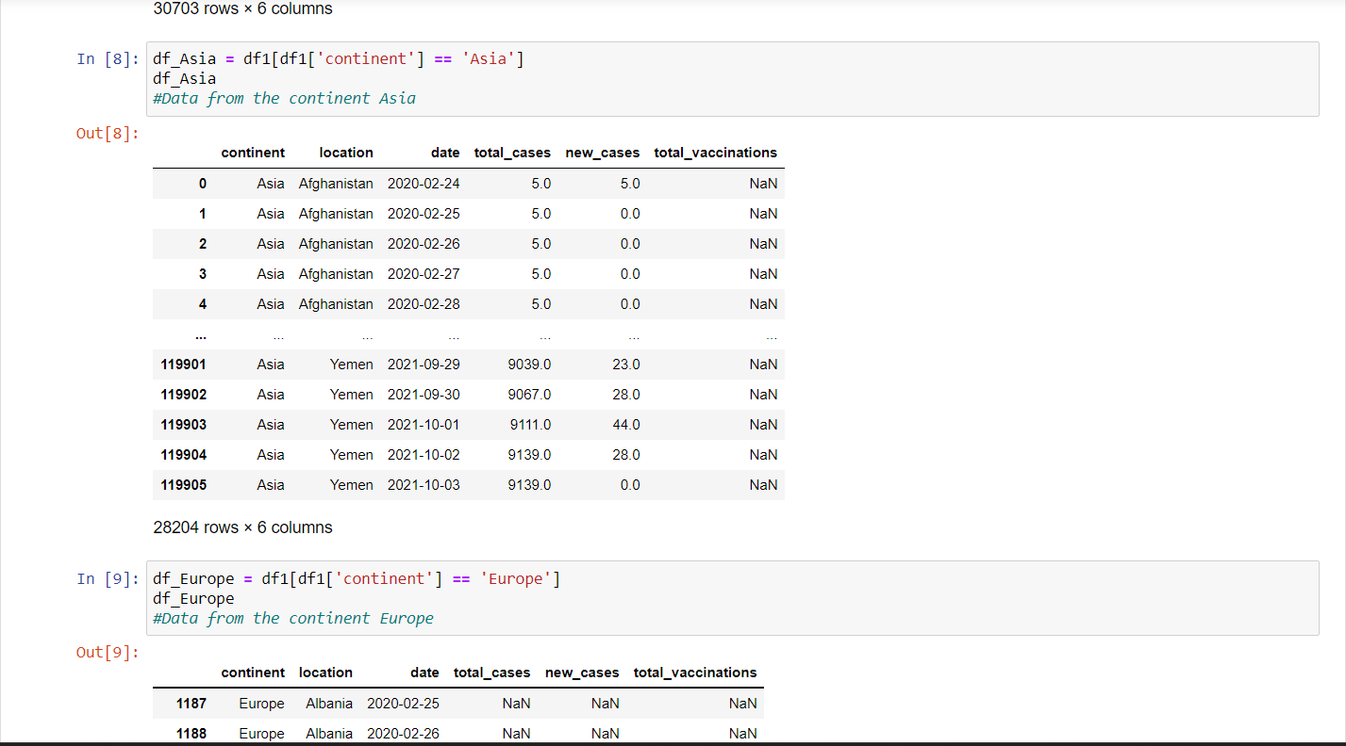

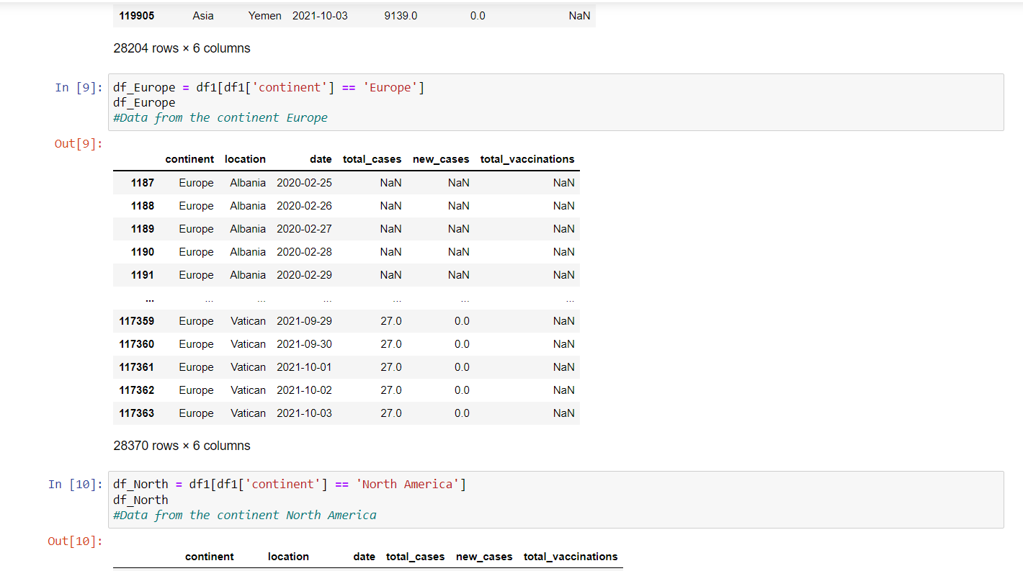

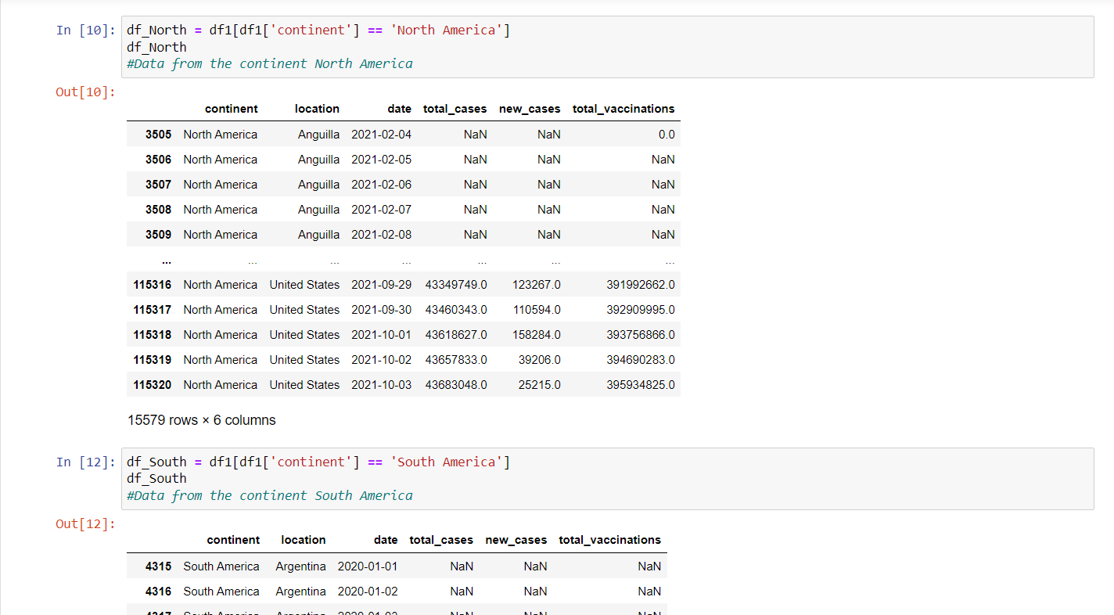

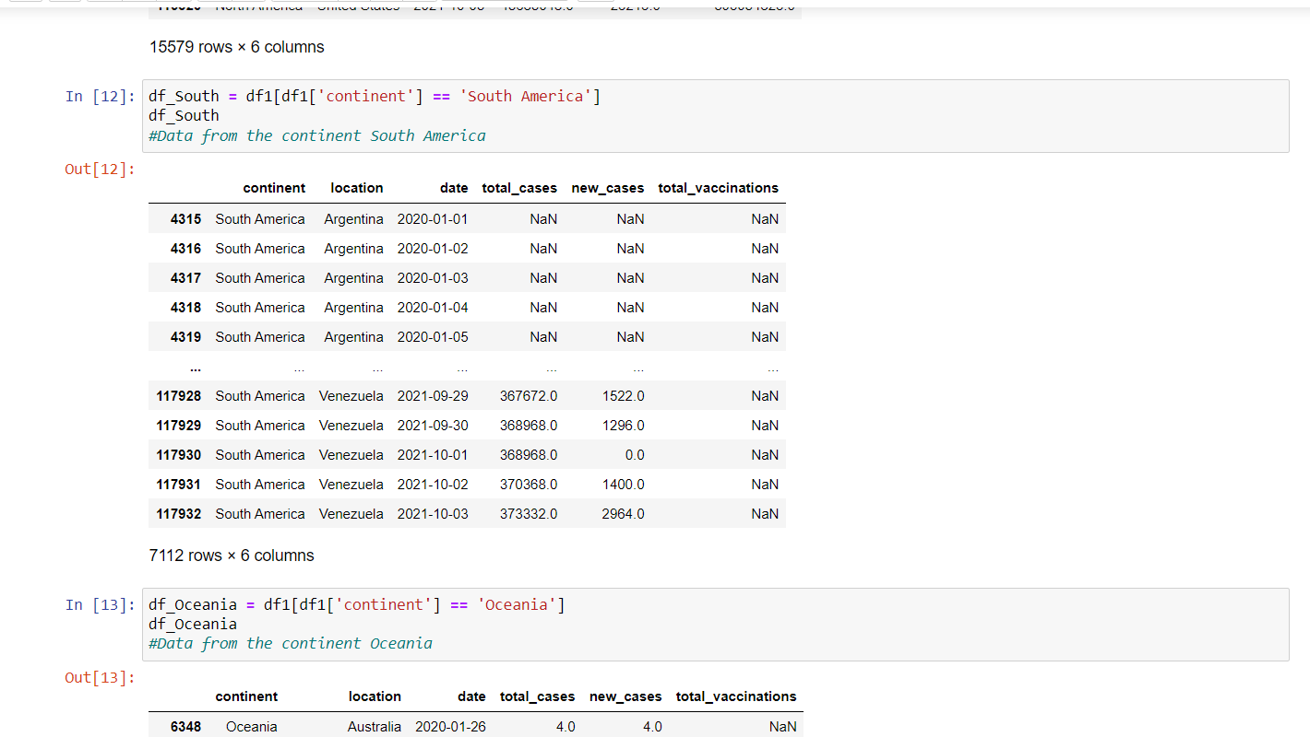

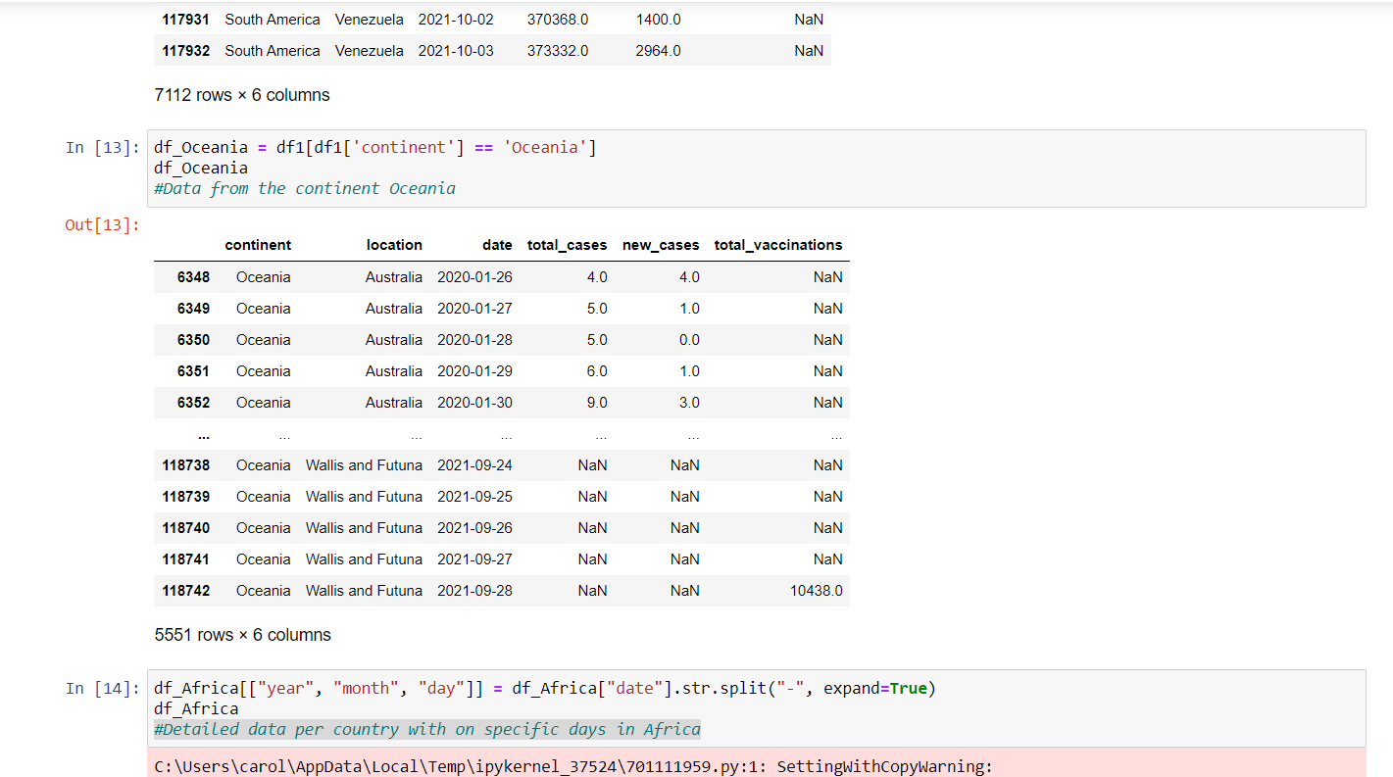

After this I wanted to make the data more detailed so I could see better the information and compare it as a line of time with the day, month and year for each continent and location. And making file paths to help search and retrieve the file location for each continent. And getting the sum of total cases and total vaccines in each continent with their respective date per country.

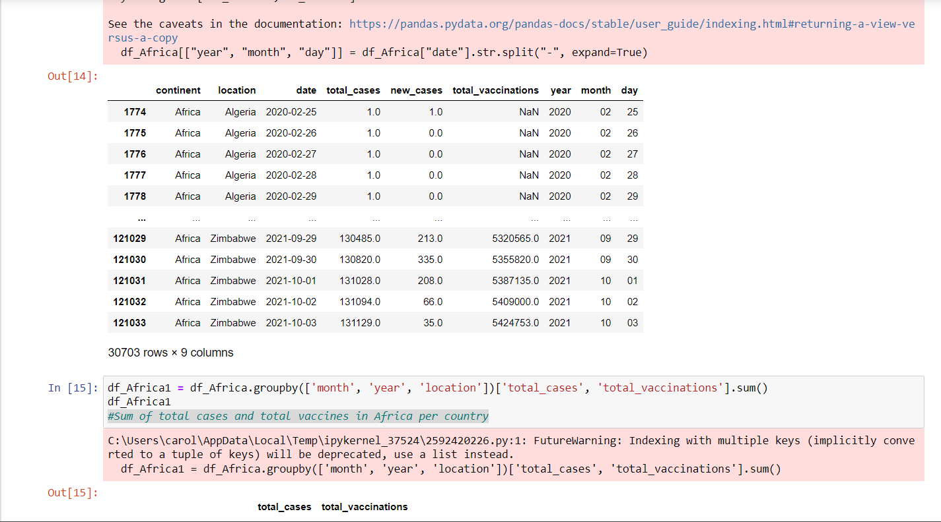

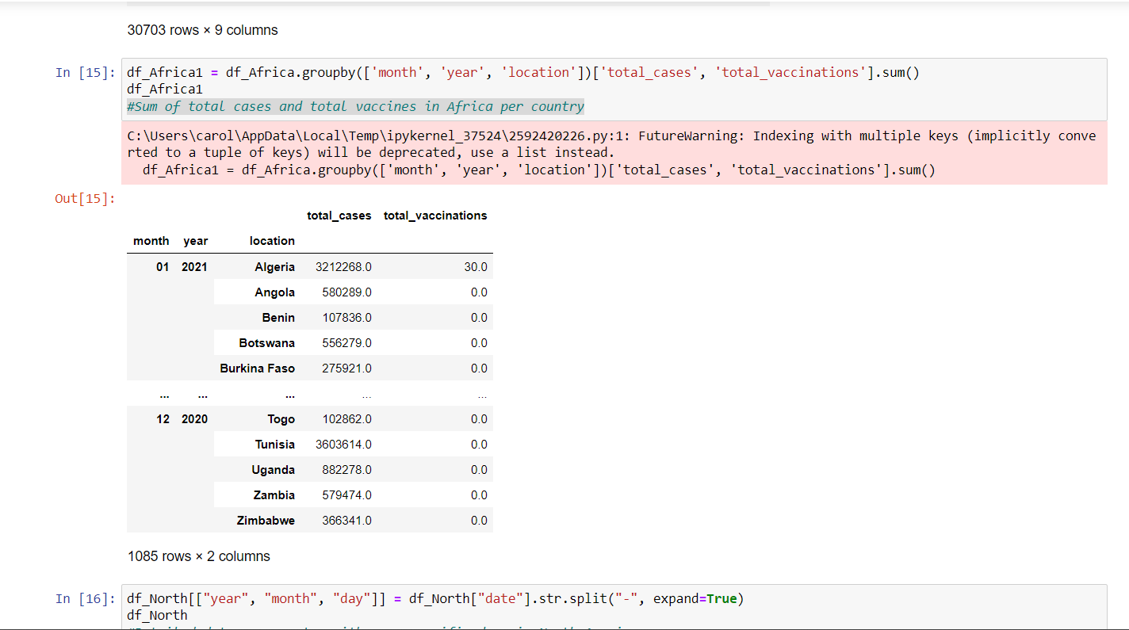

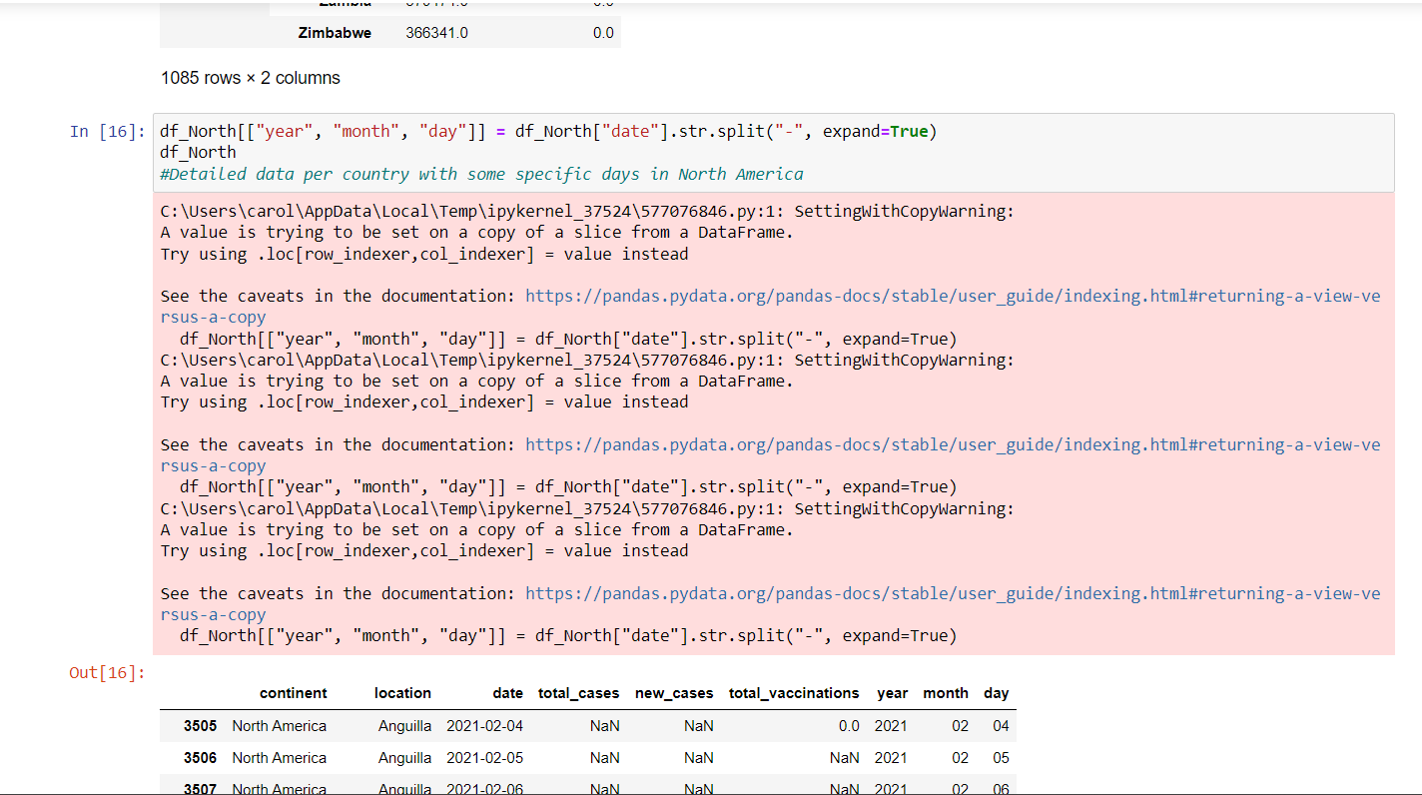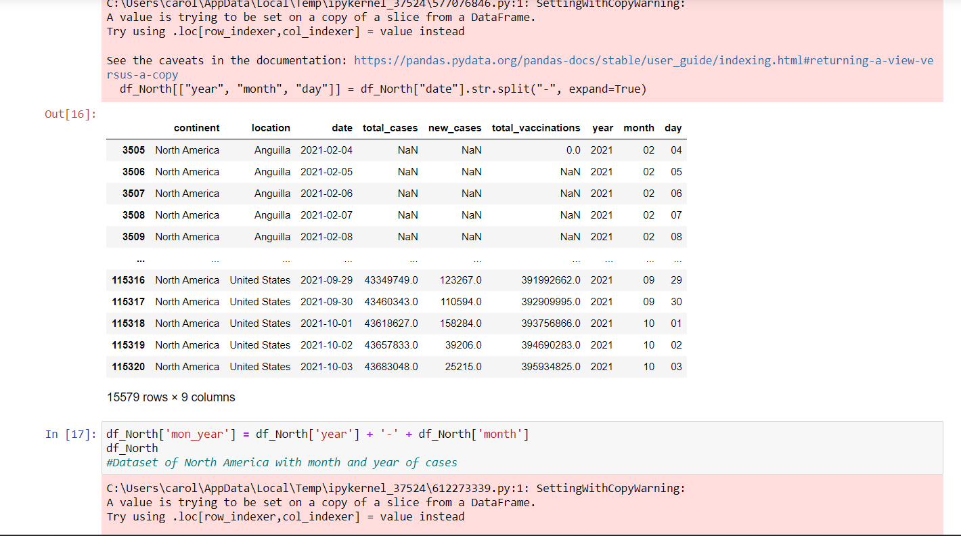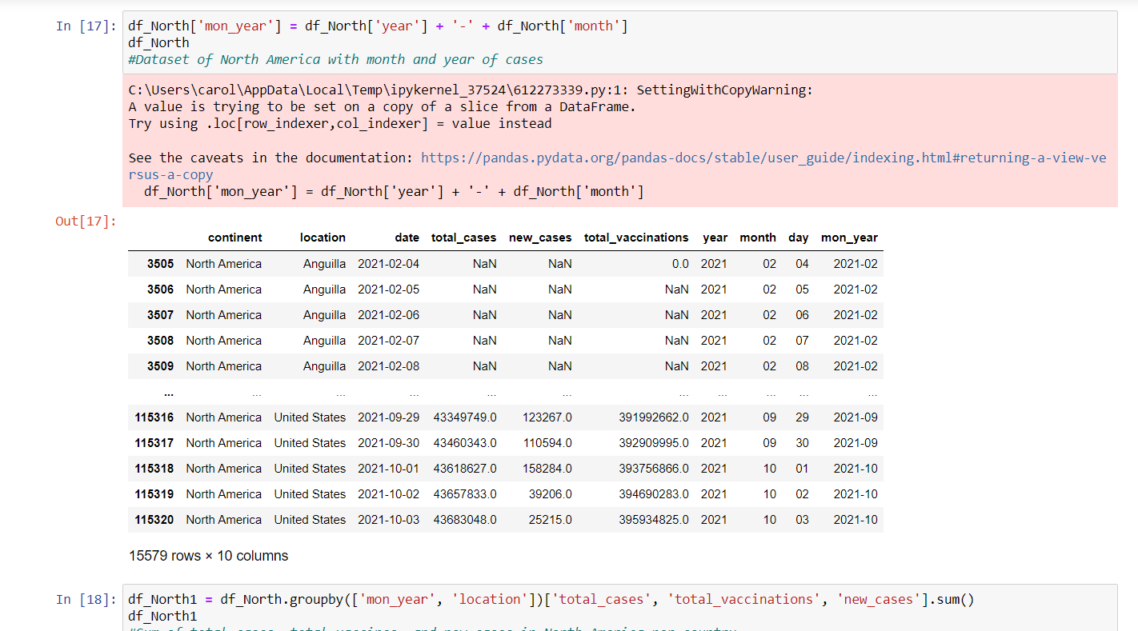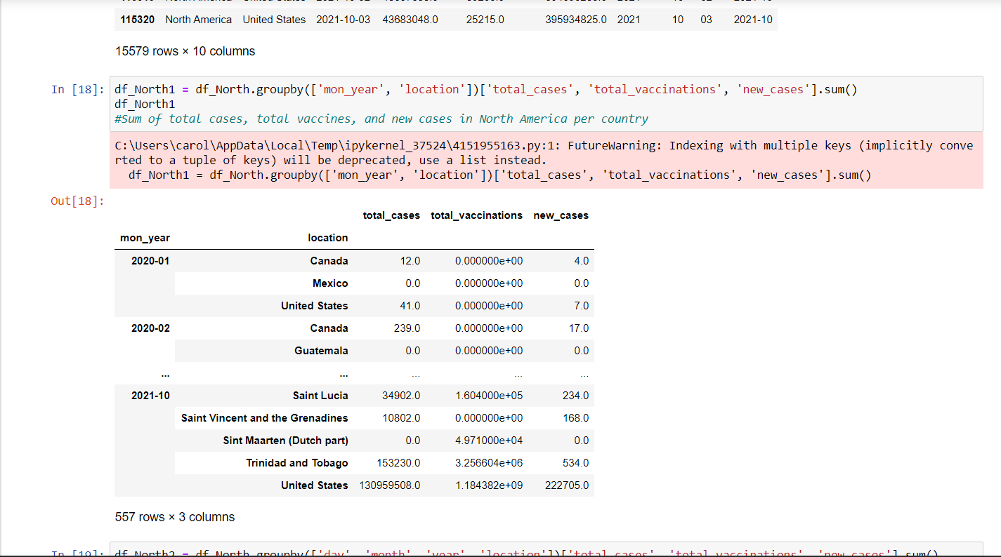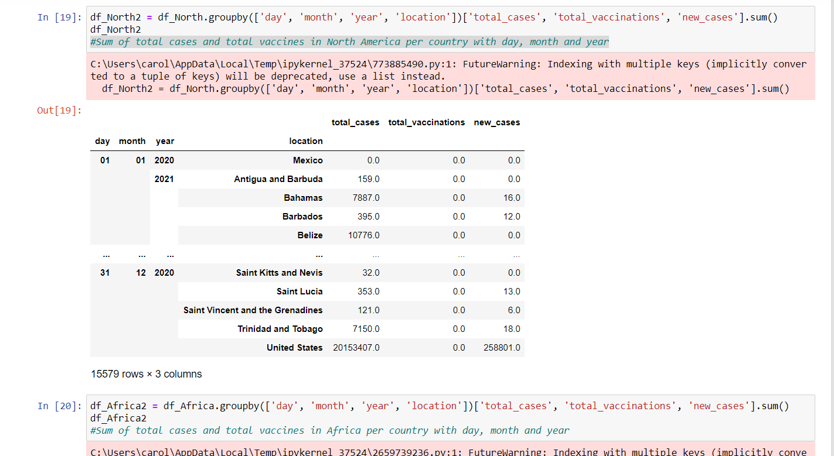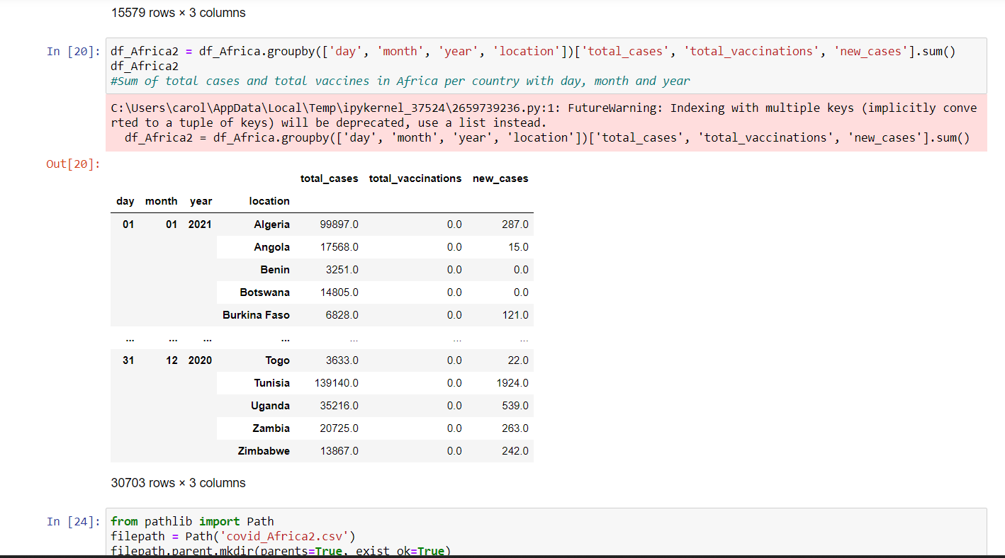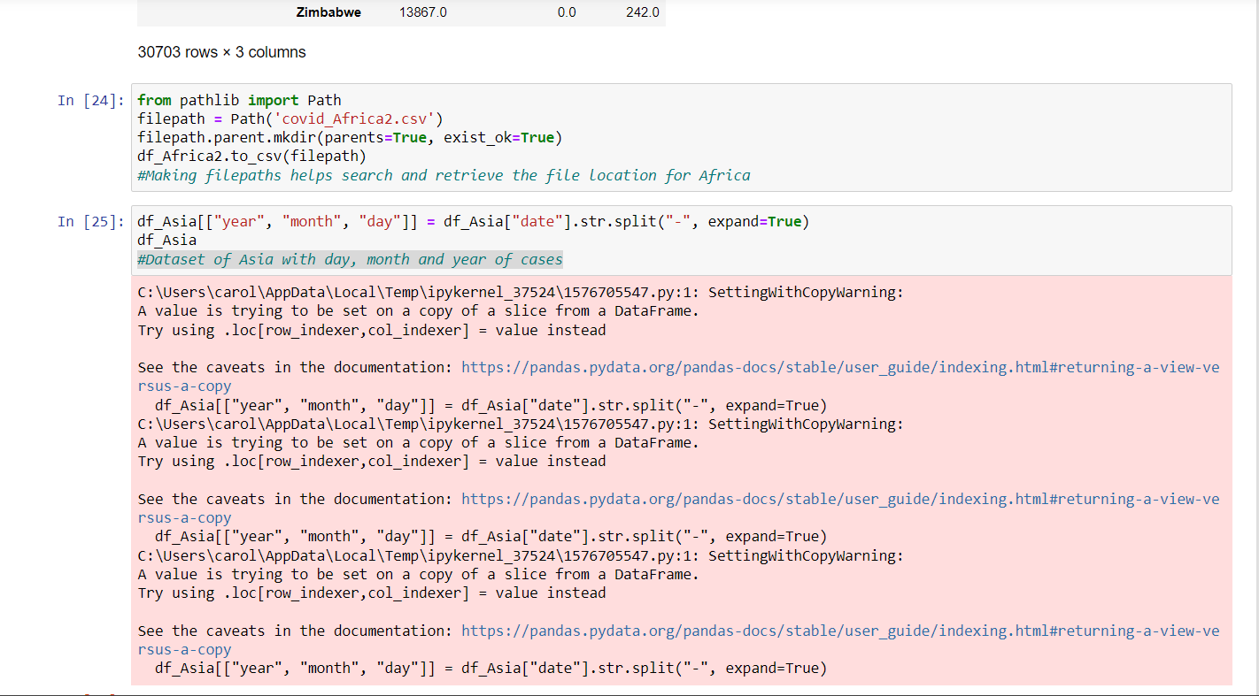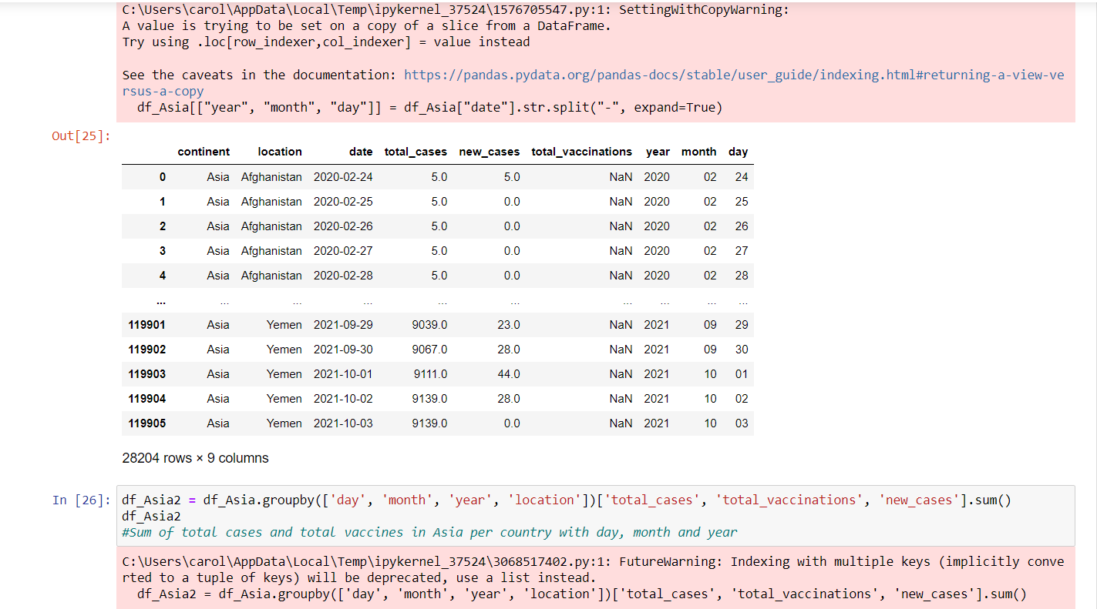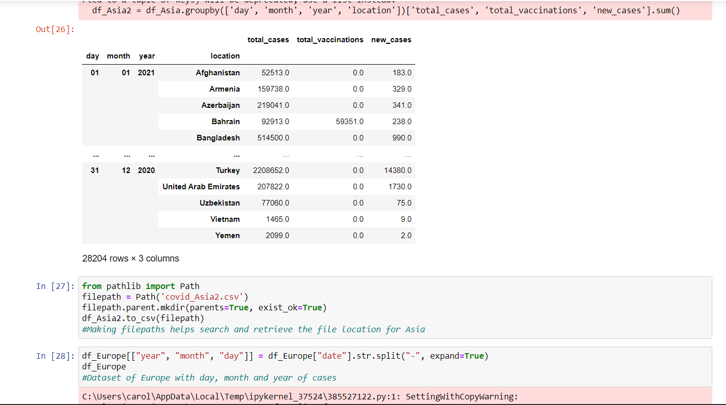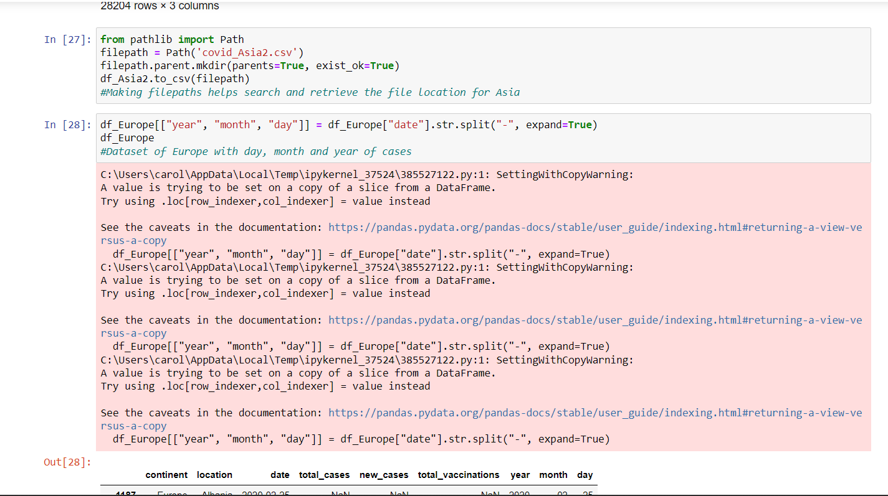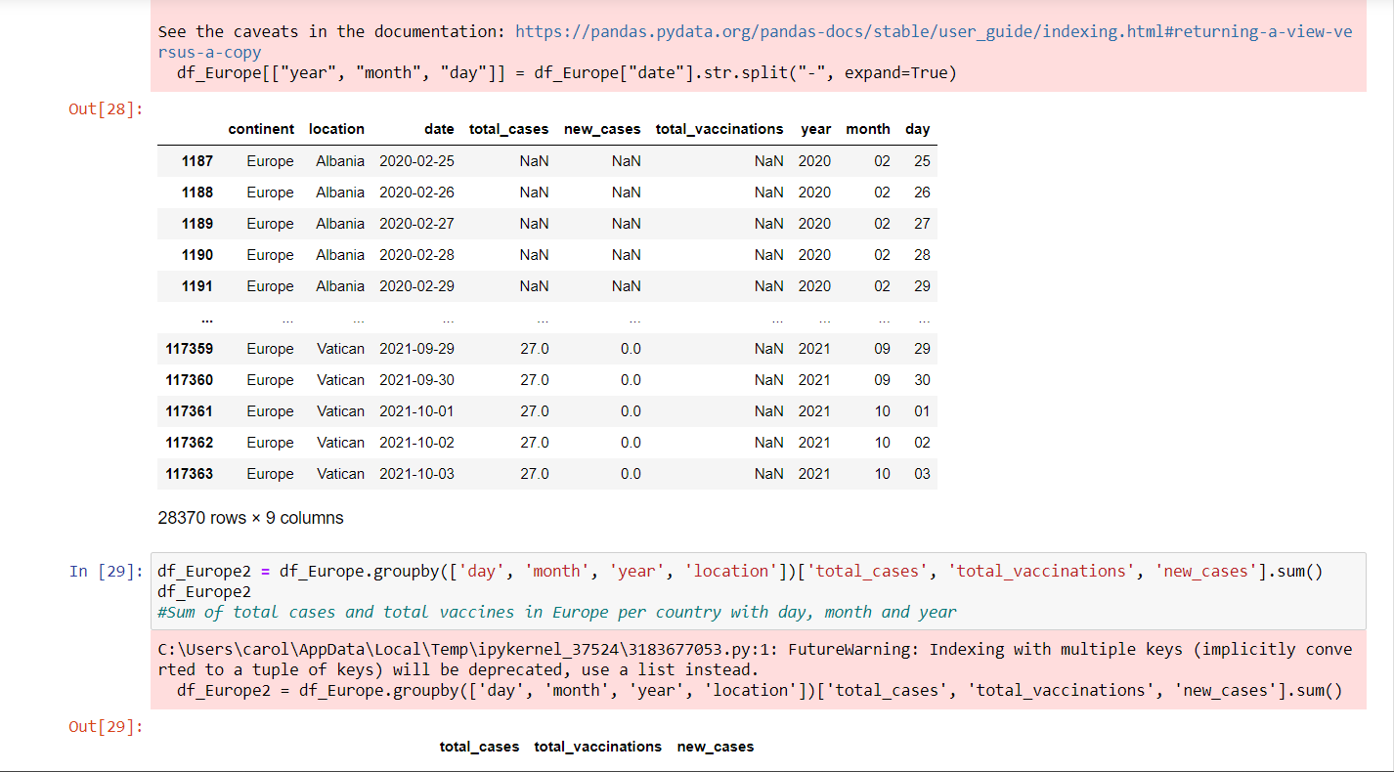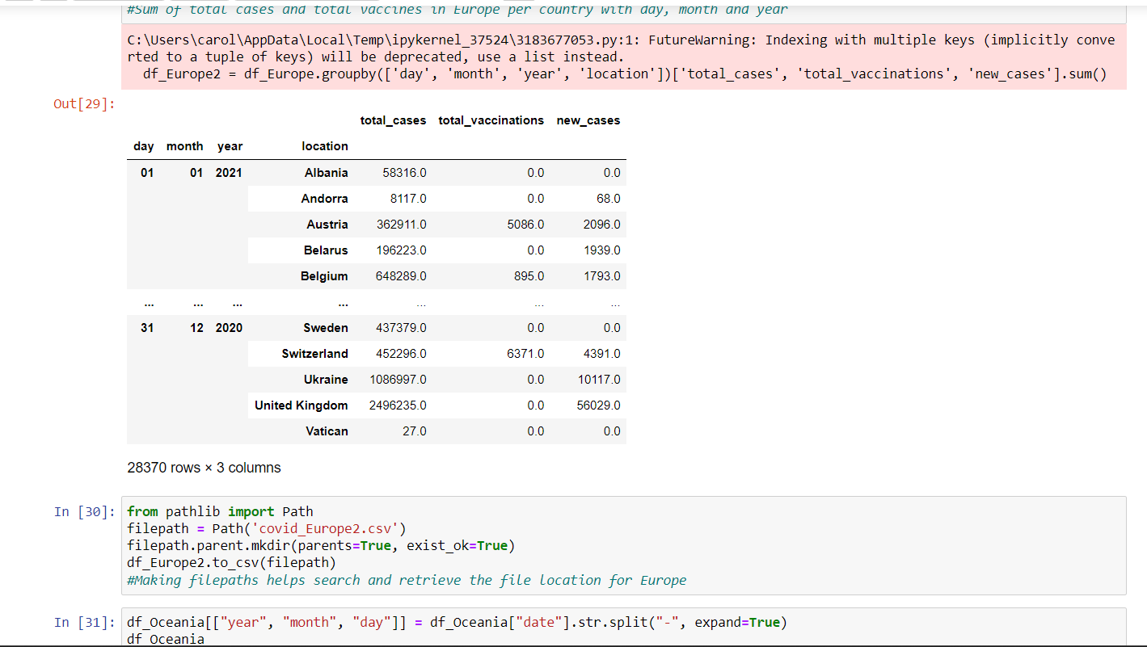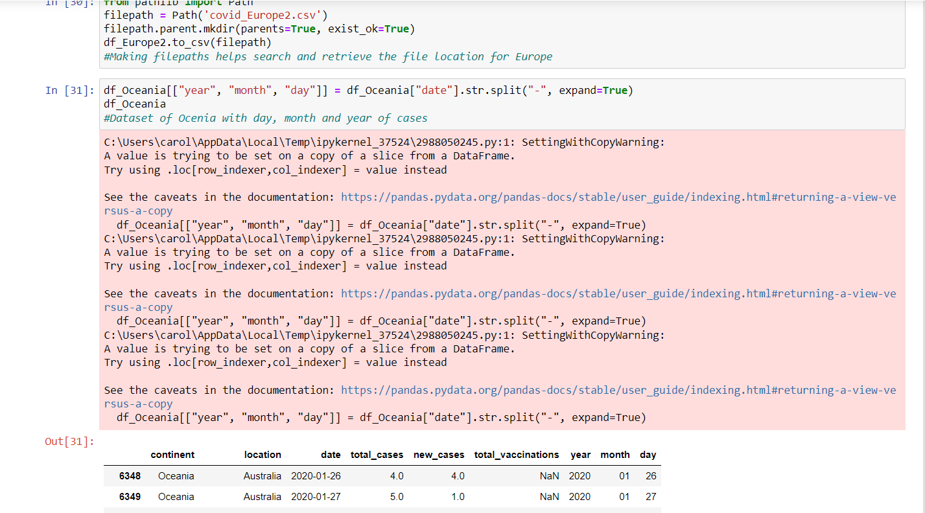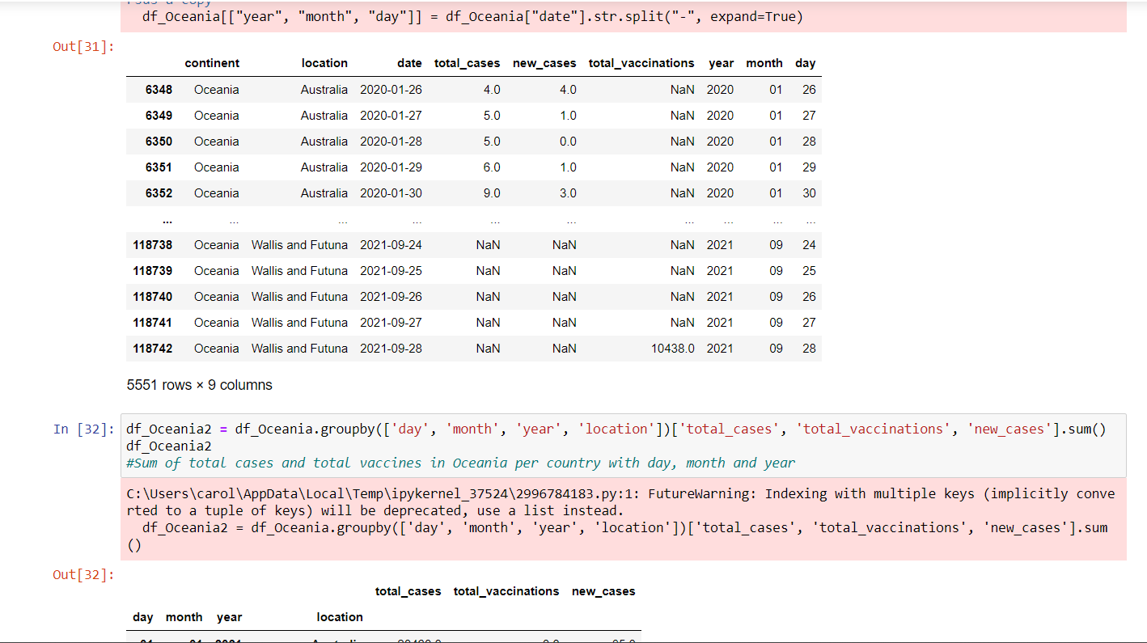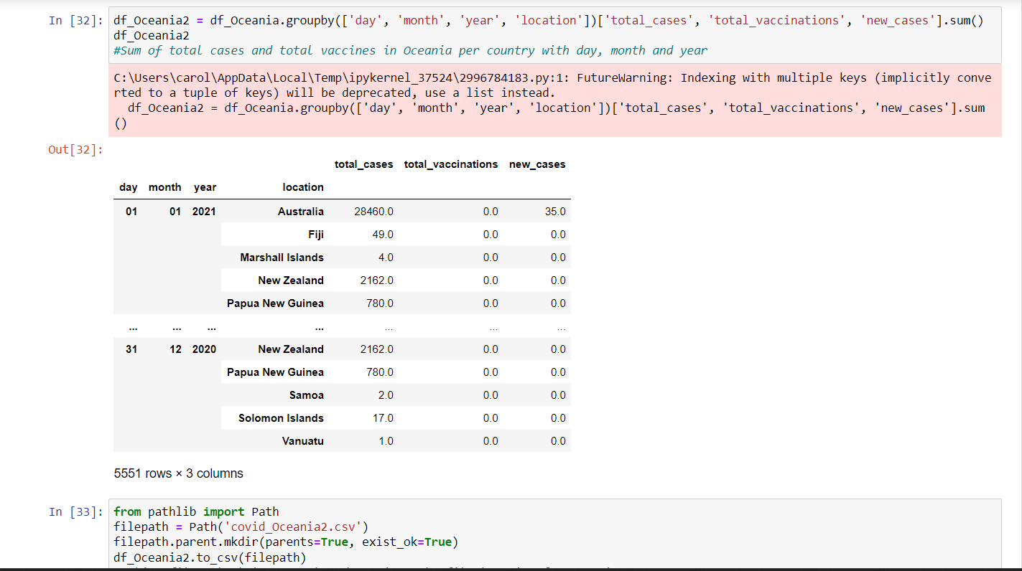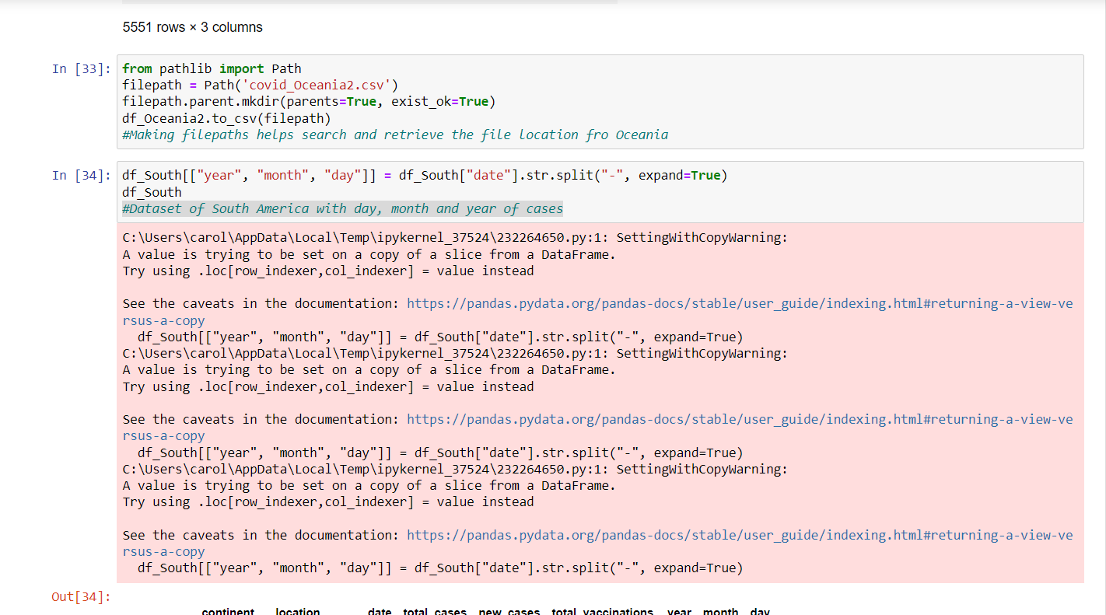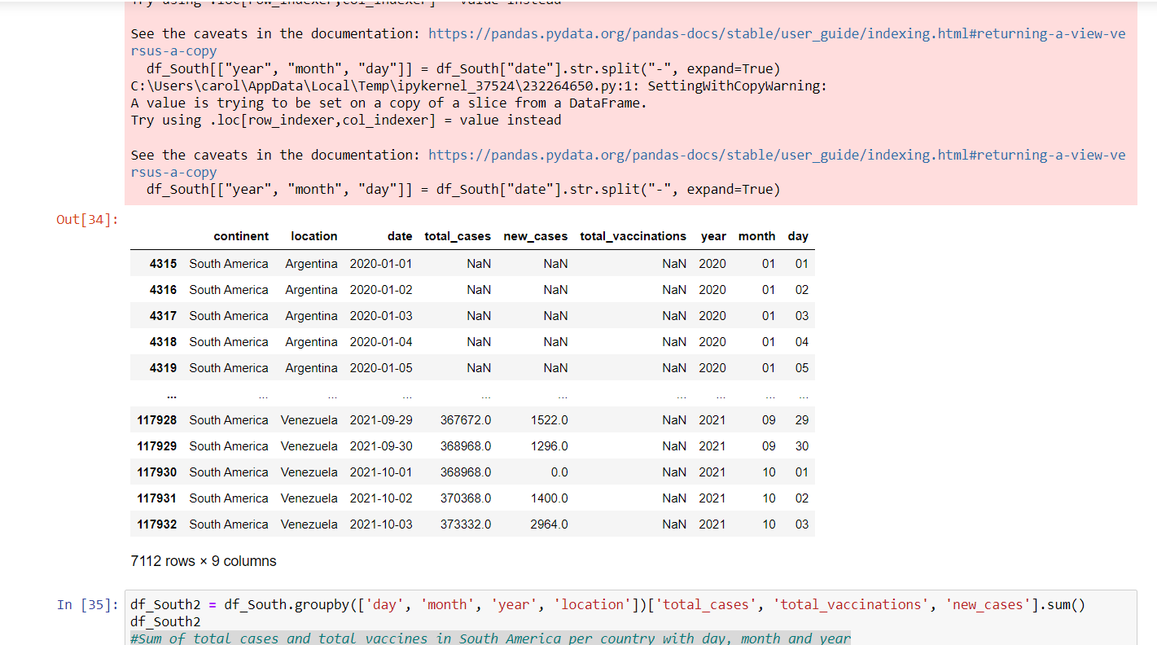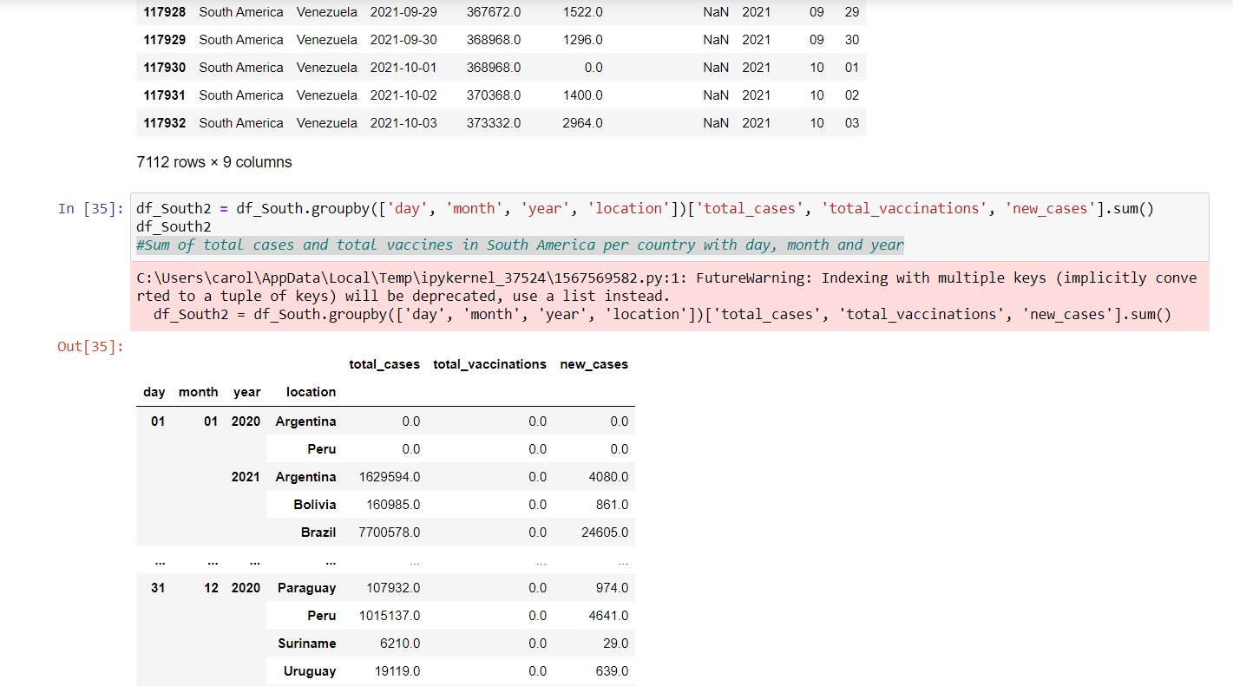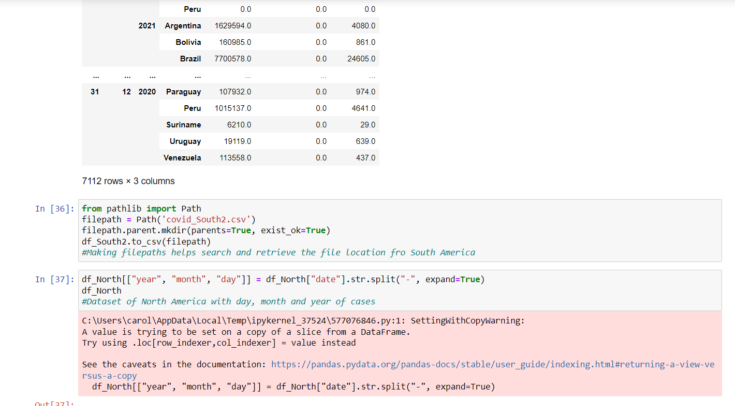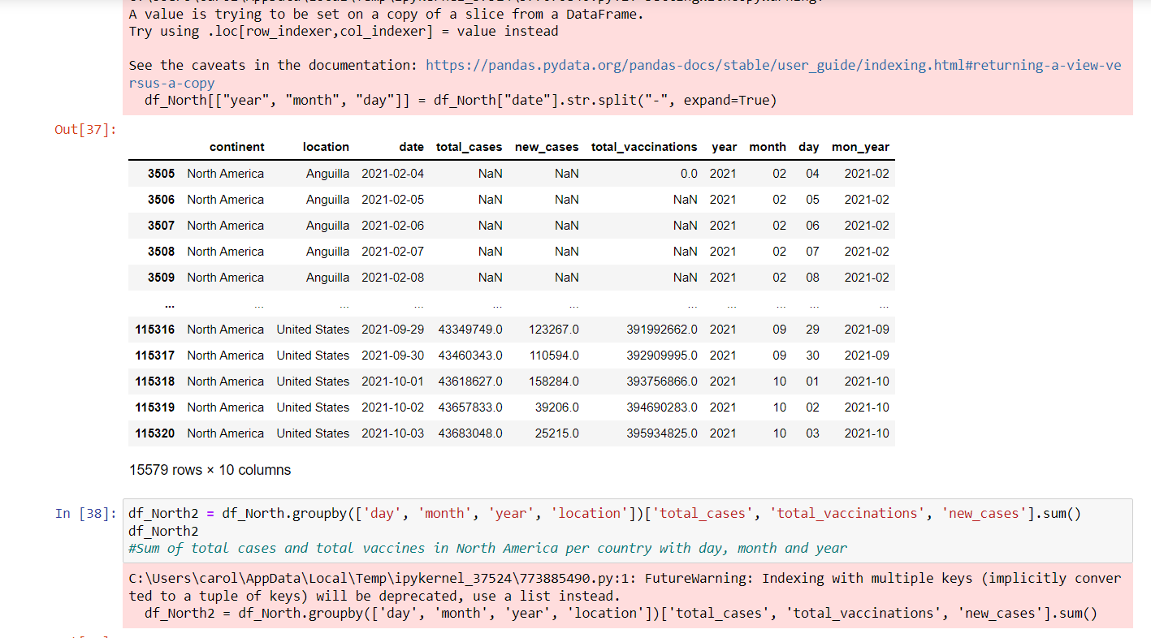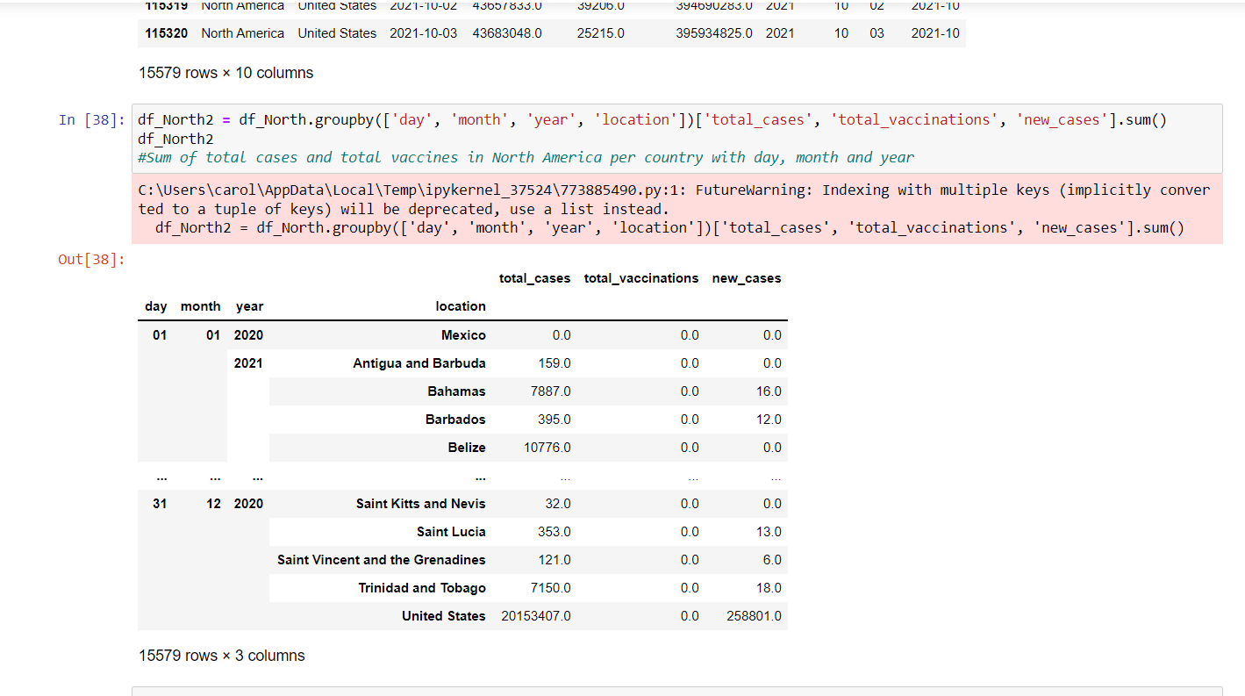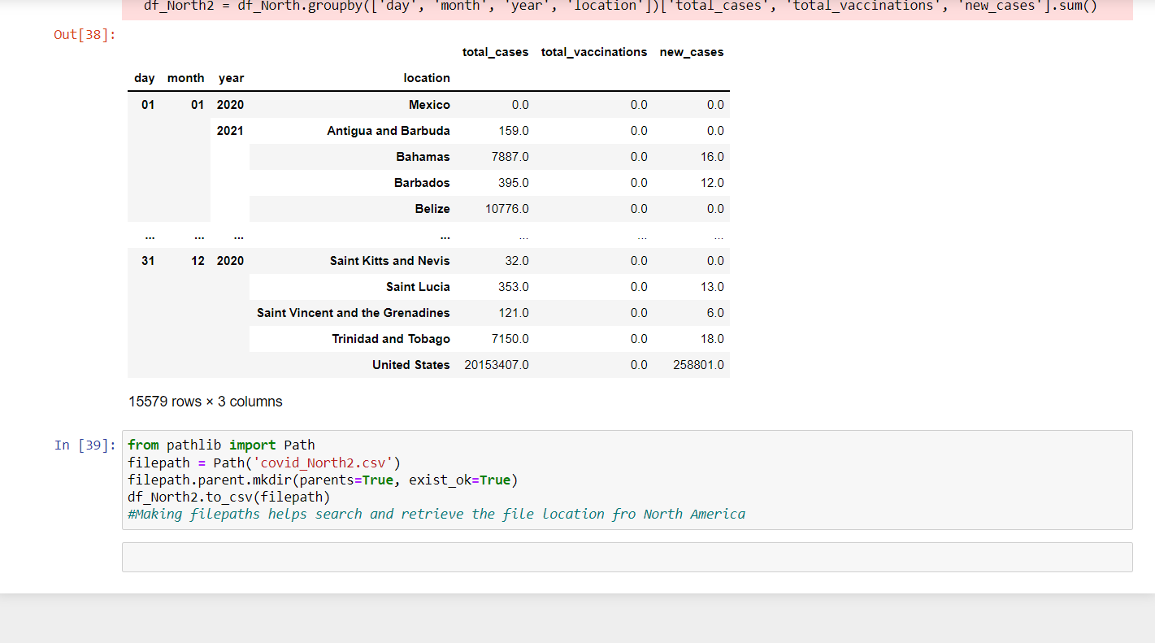

**Result and Conclusion:**

To conclude this report, as we can see from the data the continent with the most cases in the 2-year span was Asia, and the one with the least total cases was Oceania. Looking at the values from the data we were able to see that with time in Asia the cases continued to increase in that time frame, while in Oceania the cases started to decrease.